NUST SCHOOL OF MECHANICAL &MANUFACTURING ENGINEERING

## ASSIGNMENT NO:1

Name: HAMAD ARSHAD

Batch: ME-15

Section: A

Qalam Id: 481644

Course: FOP

Course Instructor: Dr. Jawad

Lab Instructor: Sir Affan.

**Task 1:**

**#include<iostream>**

**using namespace std;**

**int main(){**

**int n;**

**cout<<"enter the given number=";**

**cin>>n;**

**for(int i=1;i<=n;i++){**

**if(n%i==0){**

**cout<<i<<" ";**

**}**

**}**

**return 0;**

**}**

**Output:**

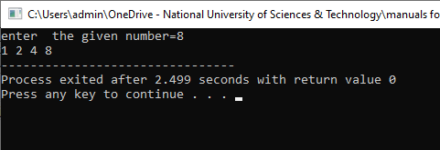

**Task 2:**

**#include <iostream>**

**int main() {**

**int x = 5;**

**int y = 10;**

**if (x == 5)**

**if (y == 10)**

**std::cout << "x is 5 and y is 10" << std::endl;**

**else**

**std::cout << "x is not 5" << std::endl;**

**return 0;**

**}**

**Output:**

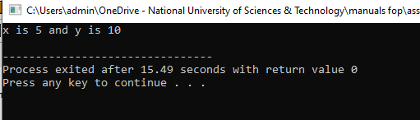

**TASK 3:**

**#include<iostream>**

**using namespace std;**

**int main(){**

**int num;**

**cout<<"enter the given number ";**

**cin>>num;**

**if( num>10 && num<=20)**

**{**

**cout<<"yes";**

**}**

**else{**

**cout<<"no";**

**}**

**return 0;**

**}**

**Output:**

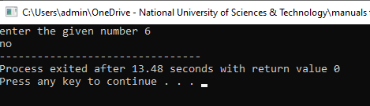

**TASK 4:**

**#include<iostream>**

**using namespace std;**

**int main(){**

**int n;**

**int num;**

**cout<<"Please enter the number"<<endl;**

**cin>>n;**

**for(int i=n; i>=2; i-=1){**

**for(int j=2; j<=i; j+=1){**

**if(i%j==0 && i==j){num = j;}**

**if(i%j==0){break;}**

**}**

**if(num == i){break;}**

**}**

**cout<<"The largest prime is: "<<num<<endl;**

**return 0;**

**}**

**Output:**

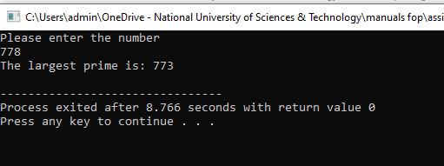

**TASK 5:**

**#include<iostream>**

**#include <cstring>**

**using namespace std;**

**int main(){**

**char num1[10];**

**char num2[10];**

**cout<<"Please enter the strings"<<endl;**

**cin>>num1;**

**cin>>num2;**

**int p = strlen(num2)-1;**

**char num3[p];**

**if(strcmp(num1, num2)==0){**

**for(int i=0; i<10; i+=1){**

**num3[p]=num2[i];**

**p=p-1;}**

**cout<<"The reversed string is: "<<num3<<endl;}**

**else{cout<<"the strings are not the same"<<endl;}**

**return 0;**

**}**

**Output:**

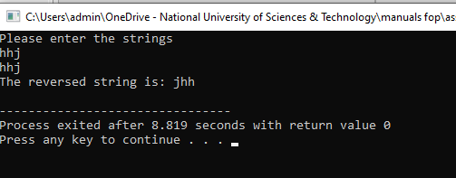

**TASK 6:**

**#include <iostream>**

**using namespace std;**

**int main() {**

**// Initialize dividend and divisor**

**int dividend ;**

**cout<<"enter the dividend";**

**cin>>dividend;**

**int divisor ;**

**cout<<"enter the divisor";**

**cin>>divisor; // Initialize quotient**

**int quotient = 0; // Perform division without using /**

**while (dividend >= divisor) {**

**dividend -= divisor;**

**quotient++;**

**} // Display the final result**

**std::cout << "Quotient: " << quotient << std::endl;**

**return 0;**

**}**

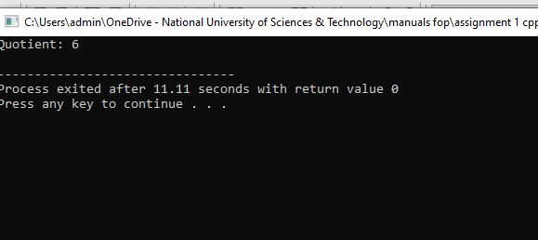

**Task 7:**

**#include<iostream>**

**#include<string.h>**

**using namespace std;**

**int main(){**

**string S,newS;**

**int i,j;**

**cout<<"Enter any string:"<<endl; //input a string from the user**

**cin>>S;**

**cout<<endl;**

**for(i=0;i<S.length();i++){**

**for( j=0;j<S.length();j++){**

**if(S[i]==S[j]){**

**break; }**

**} if(i==j){**

**newS+=S[i]; }**

**} cout<<"sting without duplicate characters: "<<newS; //cout the new string**

**return 0;**

**}**

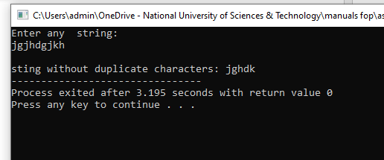

**Task 9:** **#include <iostream>**

**using namespace std;**

**int main(){**

**int aryr[10];**

**int X, inp=0, size, i=0;**

**bool flag=false;**

**while(inp != -1){**

**cout<<"Enter a Value for Array, Press -1 to Quit!";**

**cin>>inp;**

**if(inp==-1){**

**break;**

**}**

**else{**

**aryr[i]=inp;**

**i++;**

**}**

**}**

**cout<<"Enter Number for Which Triplet is Required: ";**

**cin>>X;**

**size=sizeof(aryr)/sizeof(aryr[0]);**

**for (i = 0; i < size - 2; ++i) {**

**for (int j = i + 1; j < size - 1; ++j) {**

**for (int k = j + 1; k < size; ++k) {**

**if (aryr[i] + aryr[j] + aryr[k] == X) {**

**cout << "Triplet: " << aryr[i] << " " << aryr[j] << " " << aryr[k] << endl;**

**flag=true;**

**}**

**}**

**}**

**}**

**if(flag==false){**

**cout<<"Triplet not Found!";**

**}**

**}**

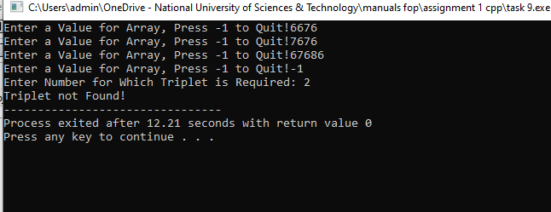

**Task 8:**

**int a[] = {1, 2, 3, 4, 5};**

**int size = 5;**

**cout << "Array elements before adding more elements: ";**

**for (int i = 0; i < size; ++i) {**

**cout << a[i] << " ";**

**}**

**int newSize = size + 3;**

**int* newArray = new int[newSize];**

**for (int i = 0; i < size; ++i) {**

**newArray[i] = a[i];**

**}**

**newArray[size] = 6;**

**newArray[size + 1] = 7;**

**newArray[size + 2] = 8;**

**cout << "Array elements after adding more elements: ";**

**for (int i = 0; i < newSize; ++i) {**

**cout << newArray[i] << " ";**

**}**

**delete[] newArray;**

**}**

**Output:**

